Task1:Is Python compiled language or an interpreter?
Python seems like an interpreter to the user but it is combination of both the compiler and interpreter.
Working:
.py file -> Byte code(.pyc) {.cpython.pyc vanera save hunxa in __pycache__ folder} -> Python Virtual Machine(PVC) then interprets into machine code
c/c++ ma compiler le direct machine code gartheyo vane python ma compiler + interpreter hunxa.

Sometimes the .cpython file isn’t found bcz for simple programs they are created and stored and deleted in cache.
to view the __pycache__ folder forcefully there are 2 techniques:
1.python -m FileName.py
It executes and makes the ‘.cpython’ file
2.python -m pycompile FileName.py
only makes the ‘.cpython’ file and we need to do:
python FileName.cpython.pyc
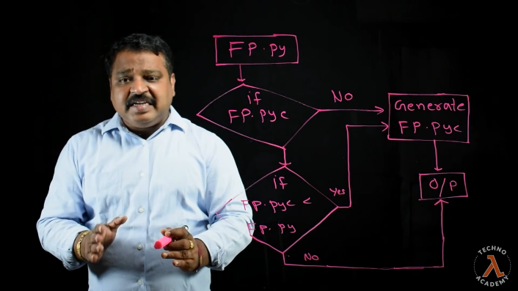
This compiler + interpreter combo slows the python program execution but increases developer productivity, program simplicity and other good benefits.
Jit compiler monitors the program and identifies frequently executed code(hot code). This hot code is compiled into machine code at runtime which is reused for subsequent executions, avoiding repeated interpretation. Cpython doesn’t uses JIT while Pypy uses it

Task2: Abstract Syntax Trees(AST)
It’s the intermediate representation of source code as a tree structure. AST serves as an intermediate representation of the code and is generated by a compiler or interpreter. The AST is then converted into byte codes.
x = 5 + 3 is built as sth like:
=
/ \
x +
/ \
5 3

The compilation pipeline is:
Source Code -> Lexer (tokens)-> Parser -> AST -> Bytecode / Machine Code

Suppose for our source code. x = 5 + 3. It is tokenized as “x” “=” “5” “+” “3” . now it is parsed according to the rules of language(python) here. Now AST is made as:
Assign
/ \
a Add
/ \
b 2
Python exposes AST using built in ast module.
import ast
code = "x = 5 + 3"
tree = ast.parse(code)
print(ast.dump(tree, indent=2))
Its output is:
Module(
body=[
Assign(
targets=[Name(id='x')],
value=BinOp(
left=Constant(value=5),
op=Add(),
right=Constant(value=3)
)
)
]
)
AST tree is represented as =>
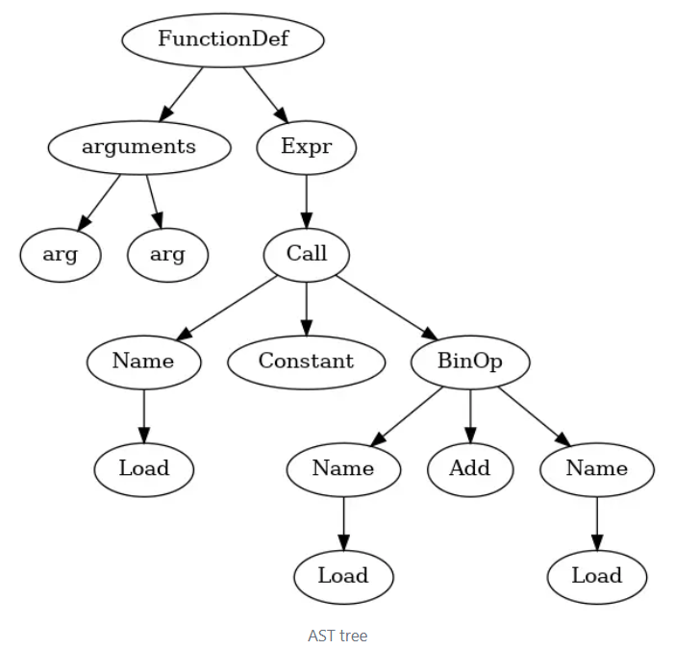

import ast
code = '''
def greet(name):
print("Hello, " + name + "!")

greet("John")
'''
tree = ast.parse(code)
print(ast.dump(tree))

("Module(body=[FunctionDef(name='greet', args=arguments(posonlyargs=[], "
"args=[arg(arg='name')], kwonlyargs=[], kw_defaults=[], defaults=[]), "
"body=[Expr(value=Call(func=Name(id='print', ctx=Load()), "
"args=[BinOp(left=BinOp(left=Constant(value='Hello, '), op=Add(), "
"right=Name(id='name', ctx=Load())), op=Add(), right=Constant(value='!'))], "
"keywords=[]))], decorator_list=[]), Expr(value=Call(func=Name(id='greet', "
"ctx=Load()), args=[Constant(value='John')], keywords=[]))], type_ignores=[])")

Module means that our python file is treated as a module. Inside body there’s a function defn n fn call. The name and arg parameter denote the name and arguments respectively. Call(func=Name(id='print' is calling print statement and BINOP does the binary operation(addition here). Expr is used to show the calling operation.
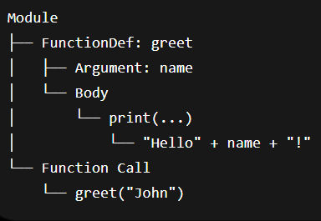
Ast can detect errors that the parser cannot detect.

Diamond Problem

